## Using MPD Tool in Linux

There are two ways in which the INP_T2_Demo_Linux can be used in Linux:

1. Run the INP_T2_Demo_Linux tool from terminal with sudo command. For example:

|  |
| --- |
| sudo /home/freertos_sdk_x.y/pc_tools/MPD/bin/INP_T2_Demo_Linux |

1. Double click on INP_T2_Demo_Linux.

Add udev rules and folder access permission to enable double click feature. Execute the following steps:

Step 1: Create Libusb_T2.rules file in */etc/udev/rules.d* directory.

Step 2: Add the following rules to Libusb_T2.rules file.

**Libusb_T2.rules:**

|  |
| --- |
| SUBSYSTEMS==”usb”, ATTRS{idVendor}==”0403”, ATTRS{idProduct}==”6011”, GROUP=”users”, MODE=”0666” |

In case of Permission Denied error, execute the following step (Step 3) to extend folder access permission.

Step 3: Run the following command in the terminal to extend permissions to the selected folder and its files.

|  |
| --- |
| sudo chmod -R a+rwx /Path/to/sdk folder |

The Demo tool verifies the signature of the ELFs prior to downloading it onto the evaluation board. In case the ELFs are tampered with, an error message as shown in Figure 2 is printed on the console.

Figure 2: Signature failed window

The Talaria TWO evaluation board uses FT4323h, which is a 4-port USB to UART converter with MPSEE support. By default, these ports enumerate as COM ports in Windows OS which does not take advantage of the MPSEE capabilities of the FTDI device. The usage of these ports in the evaluation board is given in Table 1.

|  |  |
| --- | --- |
| **Port** | **Usage** |
| **A** | Connected to JTAG pins, this enables JTAG debugging using OpenOCD |
| **B** | Connected to EN_CHIP pin, which enables resetting the module |
| **C** | Connected to UART pins, this is used for programming the module |
| **D** | Connected to GPIO17 pin which is the default debug log console port |

Table 1: Usage of ports in the evaluation board

To utilize these capabilities, on Windows OS, libusbK driver needs to be installed to communicate and control the Talaria TWO module via the FTDI device on the evaluation board. The tools/applications provided by InnoPhase will use this driver.

Talaria TWO Demo Tool comes with an option of One-Click Installation of libusbk driver. In case the driver is not installed, the tool will ask for user confirmation to install this driver. If the user selects yes, various User Account Control authentication screens will appear to complete the driver installation (as shown in Figure 5).

**Note**:

1. In case of any other unwanted libusbk drivers that are already installed, the tool will automatically uninstall the unwanted drivers. This action needs User Account Control authentication screens shown in Figure 6, in addition to Figure 5. Each unwanted drives will require a separate User Account Control authentication for uninstallation.
2. Talaria TWO Evaluation Board may get detected under any already installed device driver (using libusbk driver). In this case, the tool will follow the procedure of One-Click Installation of libusbk driver (as shown in Figure 5), and might get completed a with pop-up message “Driver Installation Failed”. This will result in any one of the following two conditions:
   1. Device found: EVK serial number field in the download tool GUI is populated with appropriated EVK serial number. In this case, ignore the error message “Driver Installation Failed” and continue using the tool. To avoid this from happening repeatedly, update the driver for Talaria TWO Evaluation Board to “InnoPhase T2 Evaluation Board” driver, from device manager (as shown in Figure 3). Then, ensure the Talaria TWO Evaluation Board is detected under “libusbK USB Devices” in device manager (as shown in Figure 4).

Figure 3: Update device driver for Talaria TWO Evaluation Board

* 1. No device found: Manually install the driver using instructions from section: Installation Instructions for libusbK Driver and ensure that the Talaria TWO Evaluation Board is detected under libusbK USB Devices driver (as shown in Figure 4).

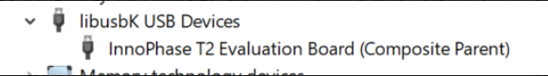

Figure 4: Talaria TWO Evaluation board under "libusbk USB Devices” driver

1. Even after successful installation of the driver, there might be possibility of the device not being identified for the first time. In this case, close the tool and re-open it. The user is notified of the same through a pop-up message: No Device Connected. Please close and reopen the Tool.

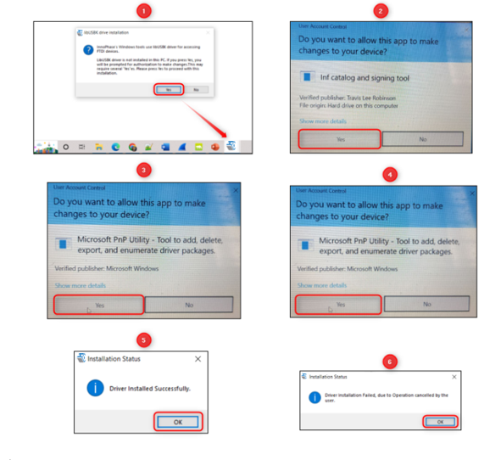

Figure 5: User Account Control authentication to complete driver installation

From Figure 5:

Image 1: Pop-up message for user confirmation, where the user chooses Yes.

Image 2: On clicking Yes, windows authentication prompt appears on Task bar.

Image 3: Click on Yes in the next window.

Image 4: Click Yes for the subsequent User Account Control authentication to complete driver installation.

Image 5: Pop-up message indicating successful driver installation.

Image 6: Pop-up message, in case of user chooses No.

Figure 6: User Account Control authentication to delete unwanted libusbk drivers

From Figure 6:

Image 1: Pop-up message for user confirmation, where the user chooses Yes.

Image 2: Click Yes for the subsequent User Account Control authentication to delete unwanted drivers.

Image 3: Pop-up message indicating successful driver installation.

Image 4: Pop-up message, in case of user chooses No.

In case the driver installation using Talaria TWO Demo Tool is not successful, the user can manually install the driver using instructions in section: Installation Instructions for libusbK Driver. Instructions to change driver is available in section: Update Driver from libusK Driver to COM Port.